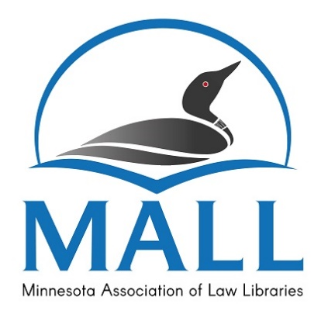 | Minnesota Association of Law Libraries  Scholarship Application

Applicant Information

- Name: ______________________________________________________________________________

- Home Address: _____________________________________________________________________

- Phone: ___________________________

- Email: _____________________________________________________

- Educational Institution: _____________________________________________________________

- Degree Program: ___________________________________________________________________

- MALL Membership (years): ________________________________

- MALL Activities (include dates of service): __________________________________________

______________________________________________________________________________________

______________________________________________________________________________________

- Have you received a scholarship from MALL in the past? _____Yes _____No

- If yes, when did you receive this scholarship? ______________________________________

Please attach the following items to your application:

- A certified copy of your transcript from the school you are currently attending.
- Your current resume, listing your education, work experience, professional and/or organizational memberships and activities, and publications.
- A brief personal statement discussing your career goals as a law librarian, progress in this program, and anything further that would assist the committee. This statement should be no longer than two pages, double-spaced. Please do not exceed the page limitation.
Incomplete or late applications will not be considered!

Statement of Acknowledgement

I understand and agree that if I receive a scholarship and for any reason fail to maintain the eligibility requirements or fail to complete the coursework during the semester for which the scholarship was awarded, I will immediately notify the MALL Awards Committee Chair. I also understand that, depending on the circumstances, I may be required to repay all or part of the scholarship.

Signature: _________________________________________________ Date: _______________________

Submission

Mail, fax, or email this form with all necessary attachments by 5:00 pm (CST), of the second Friday in April of the current year.

Shannon Stoneking, Chair
Dakota County Law Library
1590 Highway 55, Hastings MN 55033
Phone: 651-438-8080
Email: Shannon.Stoneking@co.dakota.mn.us

