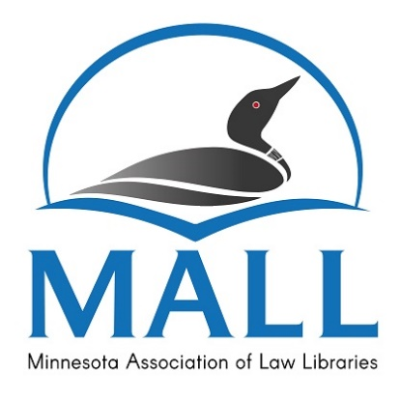 | Minnesota Association of Law Libraries  Grant Application

Applicant Information

- MALL Membership (years): ________________________________

- Name: _______________________________________________________________________________

- Work Address: ______________________________________________________________________

- Phone: ___________________________

- Email: _____________________________________________________

- Job Title: ____________________________________________________________________________

- Duties: ______________________________________________________________________________

______________________________________________________________________________________

- MALL activities (include dates of service): __________________________________________

______________________________________________________________________________________

______________________________________________________________________________________

- Name, date, and location of the program you wish to attend: _____________________

______________________________________________________________________________________

- Amount of grant requested: ___________________ (grants are made for fixed amounts only)

Please attach the following items to this application:

- For non-AALL sponsored events, a completed registration form or brochure for the program you wish to attend.
- A brief statement discussing your reasons for attending this program and how attendance will benefit you professionally.

Statement of Acknowledgement

I understand and agree that if I receive a grant from MALL, I will write an article about the program I attended for the MALL Newsletter within two months following the program.

I understand and agree that if I receive funds from another source that eliminates my need for the MALL grant, or if I cannot attend the event for any reason, I will immediately notify the MALL Awards Committee Chair. If the MALL grant has already been paid and a refund cannot be obtained, I will repay the amount of the award.

Signature: ________________________________________________ Date: ________________________

Submission

Mail, fax, or email this form with all necessary attachments no later than 30 days prior to the date of the event you wish to attend. Note: grant applications to attend the AALL Annual Meeting must be submitted by 5:00 pm (CST), of the second Friday in April of the current year.

Shannon Stoneking, Chair
Dakota County Law Library
1590 Highway 55, Hastings MN 55033
Phone: 651-438-8080
Email: Shannon.Stoneking@co.dakota.mn.us

